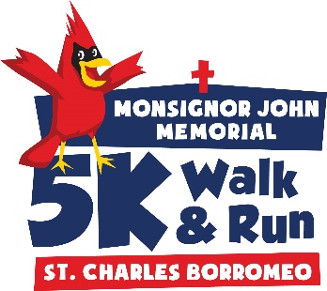
Sept 18, 2016
1:15pm – Kids’ Fun Run
@ St. Charles Hession Center

In conjunction with the Cardinal Fest 5k will be a Kids’ Fun Run!

This is primarily a chance for the young kids of our parish to join in the event with their family and friends.

Ages 0-8

NO entry fee.
NO shirts.
NO awards.

Course will be 1 or 2 big loops around the church depending on age:
0-4 years old will do 1 loop.
5-8 years old will do 2 loops.

There is no need to pre-register for the Kids’ Fun Run.
Just bring this form (signed) with you on Sept 18th.

The Kids’ Fun Run will take place just prior to the 5k at 1:15pm so everyone participating in the 5k can cheer and encourage the kids.

I know that running a road race is potentially hazardous, which could cause injury or death. I will not enter and participate unless I am physically able and properly trained, and by my signature, I certify that I am medically able to perform in this event. I assume all risks associated with participating in this event. I attest that I have read the rules and agree to abide by them. Having read this waiver, I, for myself and anyone entitled to act on my behalf, waive and release Saint Charles, Cardinal Fest, all sponsors, and their representatives from all claims or liabilities of any kind. I grant permission to use my photographs, videos, recordings or any other record of this event for any legitimate purpose.

Child Name ___________________________________________

Parent’s Signature ____________________________________________

Questions? Email: stcharlescardinalfest5k@gmail.com

